ES5 Vs ES6

ES5 stands for  **ECMAScript 5.**

ES6 stands for **ECMAScript 6**

**ECMA - E**uropean **C**omputer **M**anufacturers **A**ssociation

|  |  |  |
| --- | --- | --- |
| SR.NO. | ES5 | ES6 |
| 1. | ECMA script is a trademarked scripting language specification defined by Ecma international. The fifth edition of the  same is known as ES5 | ECMA script is a trademarked scripting language specification defined by Ecma international. The sixth edition of the same is known as ES6 |
| 2. | It was introduced in 2009. | It was introduced in 2015. |
| 3. | It supports primitive data types that are string, number, boolean, null, and undefined. | In ES6, there are some additions to JavaScript data types. It introduced a new primitive data type ‘symbol’ for supporting unique values. |
| 4. | There are only one way to define the variables by using the var keyword. | There are two new ways to define variables that are let and const. |
| 5. | It has a lower performance as compared to ES6. | It has a higher performance than ES5. |
| 6. | Object manipulation is time-consuming in ES5. | Object manipulation is less time-consuming in ES6. |
| 7. | In ES5, both function and return keywords are used to define a function. | An arrow function is a new feature introduced in ES6 by which we don’t require the function keyword to define the function. |
| 8. | It provides a larger range of community supports than that of ES6 | It provides a less range of community supports than that of ES5 |

13. i. i. Spread Operator

<html>

    <body>

    <h1>Spread Operator(...)</h1>

    <p id="demo"></p>

    <script>

        const arr = ["I","am","Indian","Citizen"];

        console.log(...arr);

    </script>

    </body>

    </html>

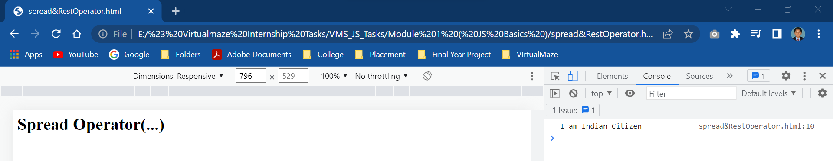

    <html>

    <body>

    <h1>Spread Operator(...)</h1>

    <p id="demo"></p>

    <script>

        const arr1 = ['a','b'];

        const arr2 = [...arr1,'c','d','e'];

        console.log(...arr2);

    </script>

    </body>

    </html>

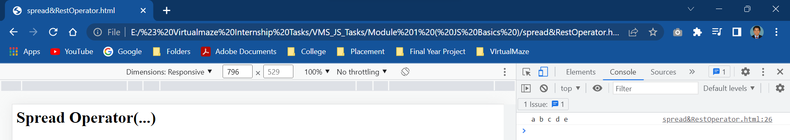

 <html>

        <body>

        <h1>Spread Operator(...)</h1>

        <h3>Clone Array Using Spread Operator</h3>

        <p id="demo"></p>

        <script>

            let arr1 = ['1','2','3'];

            let arr2 = arr1

            console.log(arr1);

            console.log(arr2);

            arr1.push(5);

            document.write("<br>Arr1 : ",arr1);

            document.write("<br><br>Arr2 : ",arr2);

        </script>

        </body>

        </html>

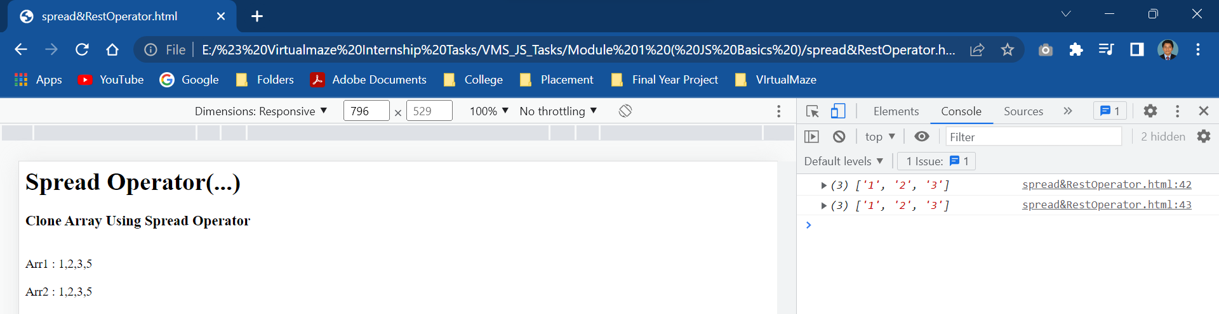

      <html>

            <body>

            <h1>Spread Operator(...)</h1>

            <p id="demo"></p>

            <script>

               let arr1 = [ 1, 2, 3];

               let arr2 = [...arr1];

               document.write("<br>Before Changing...")

               document.write("<br><br>Arr1 : ",arr1);

               document.write("<br><br>Arr2 : ",arr2);

               arr1.push(4);

               document.write("<br>,<br>Arr1 after using push 4");

               document.write("<br><br>After Changing...")

               document.write("<br><br>Arr1 : ",arr1);

               document.write("<br><br>Arr2 : ",arr2);

            </script>

            </body>

            </html>

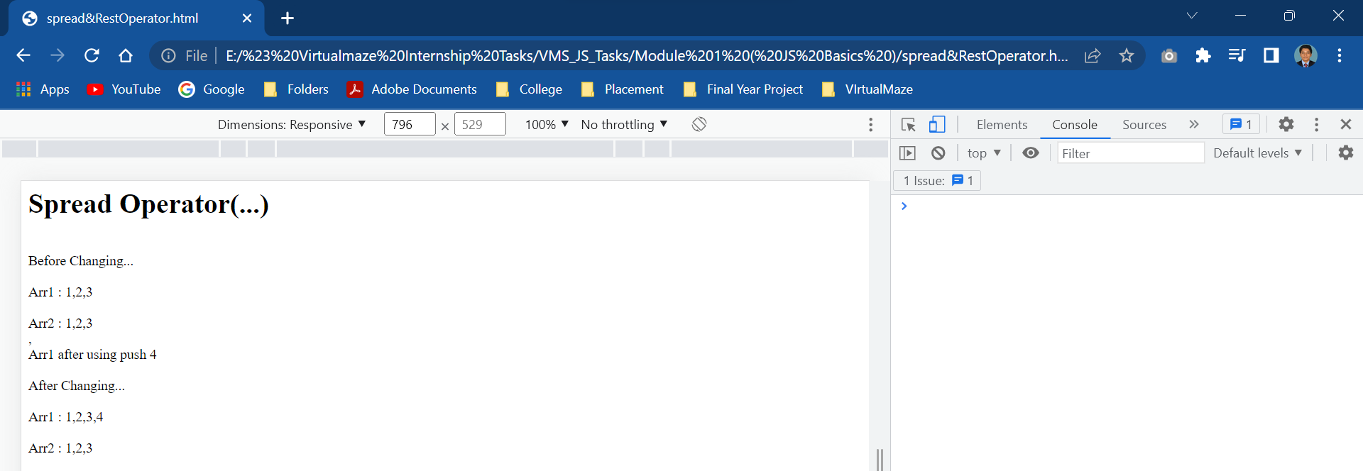

13.i.ii. Spread Operator

<html>

                <body>

                <h1>Rest Operator(...)</h1>

                <p id="demo"></p>

                <script>

                    function SumExpense(...expenses)

                    {

                        return expenses.reduce((a,b)=> a+ b);

                    }

                    let result = SumExpense(95,11,32,45,79,83);

                    document.write("Your Total Expenses : ",result);

                </script>

                </body>

                </html>

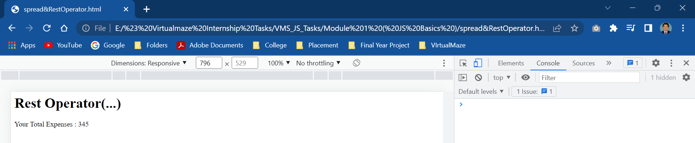

13.ii.i. Array Destructuring

<html>

    <body>

    <h1>Array Destructuring</h1>

    <p id="demo"></p>

    <script>

        let [firstname,lastname]=["prashanna","raj"];

        console.log("Firstname : ",firstname);

        firstname = "yuva";

        console.log("After Changing Firstname ")

        console.log(firstname+lastname);

    </script>

    </body>

    </html>

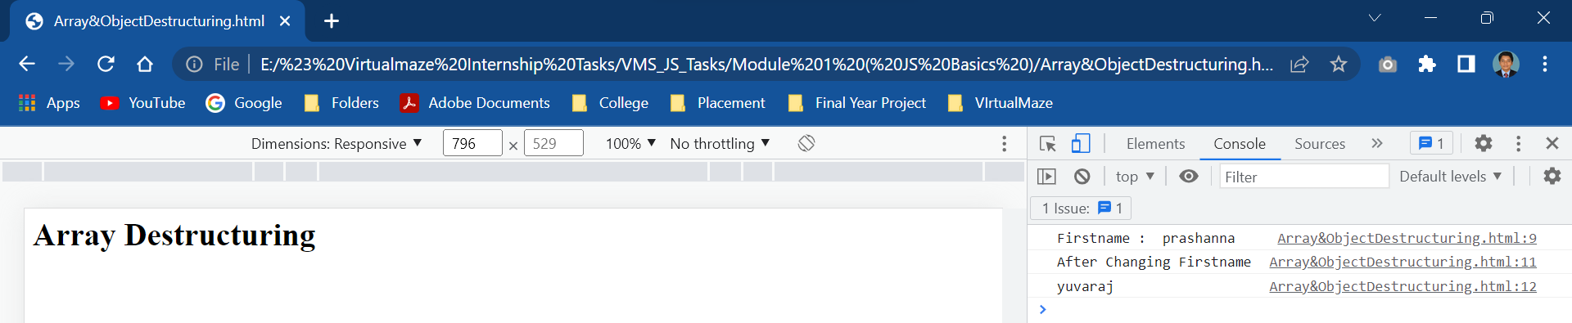

13.ii.ii Object Destructuring

  <html>

    <body>

    <h1>Object Destructuring</h1>

    <p id="demo"></p>

    <script>

        const a={

            name:"Ravikumar",

            age:48

        };

        const {name,age}=a;

        console.log("Name : ",name+"Age : ",age);

        document.write("Name : ",name+"<br>Age : ",age);

    </script>

    </body>

    </html>

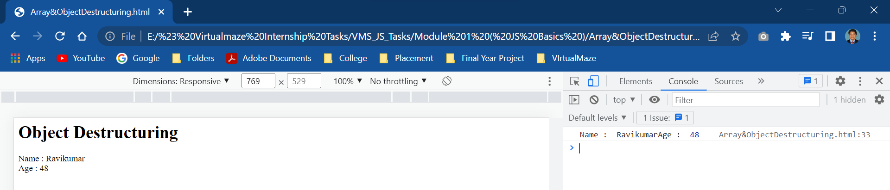

13.iii. Arrow Function

**Arrow Function with No Argument**

    <html>

        <body>

        <h1>Arrow Function</h1>

        <p id="demo"></p>

        <script>

        let text = () => console.log('Hello');

        text();

        </script>

        </body>

        </html>

### **Arrow Function with One Argument**

   <html>

            <body>

            <h1>Arrow Function</h1>

            <p id="demo"></p>

            <script>

           let text = x => console.log(x);

           text('Raj');

            </script>

            </body>

            </html>

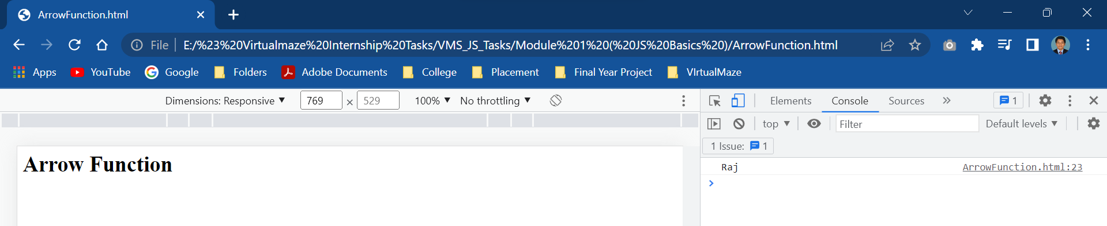

### Arrow Function as an Expression

<html>

                <body>

                <h1>Arrow Function</h1>

                <p id="demo"></p>

                <script>

               let age = 5;

               let welcome = (age < 18) ?

               () => console.log('Baby') :

               () => console.log('Adult');

               welcome();

                </script>

                </body>

                </html>

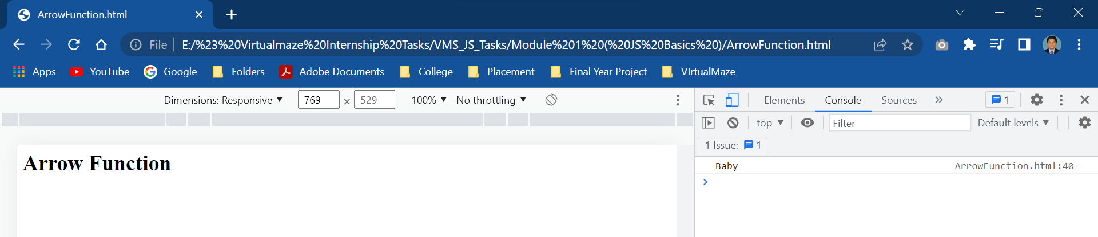

<html>

                <body>

                <h1>Arrow Function</h1>

                <p id="demo"></p>

                <script>

              let sum = (a, b) => {

                let result = a + b;

                return result;

            }

            let result1 = sum(5,7);

            console.log(result1);

                </script>

                </body>

                </html>

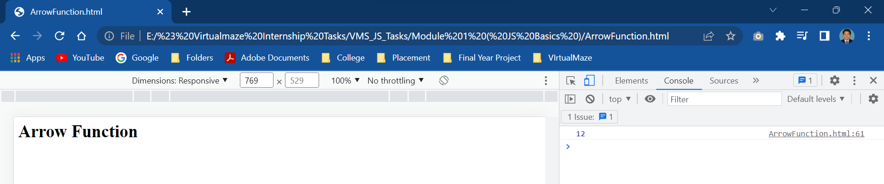

<html>

                    <body>

                    <h1>Arrow Function</h1>

                    <p id="demo"></p>

                    <script>

                  function Person() {

                    this.name = 'Ravi',

                    this.age = 25,

                    this.sayName = function () {

                        console.log(this.age);

                        let innerFunc = () => {

                            console.log(this.age);

                        }

                        innerFunc();

                    }

                }

                const x = new Person();

                x.sayName();

                    </script>

                    </body>

                    </html>

